“Inspiring Growth through Adventure”
Bespoke residential visits and activity days

www.vineyhilladventure.org
(01594) 516162

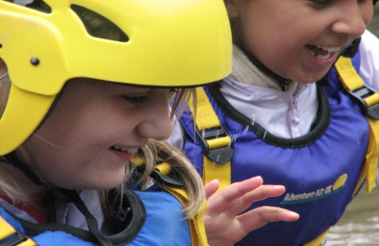 | 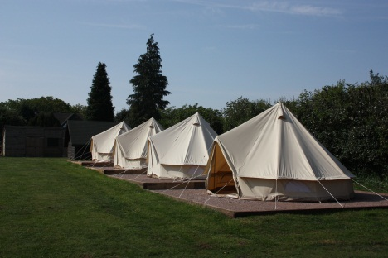 | 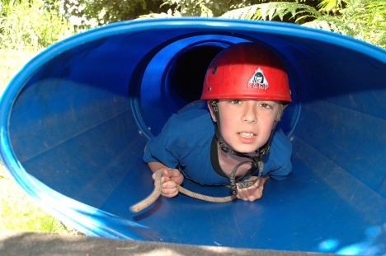
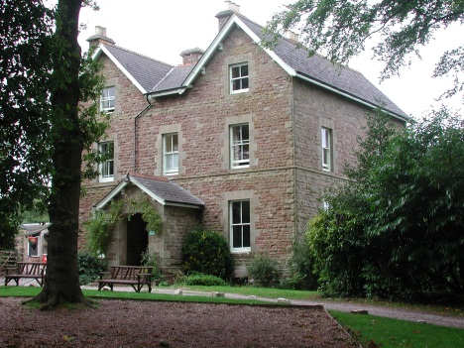 | Booking Information  2018 | 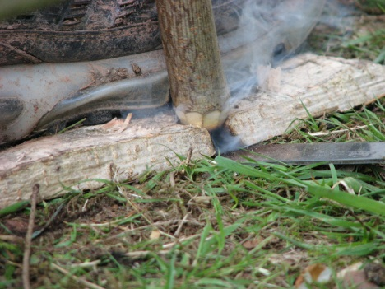
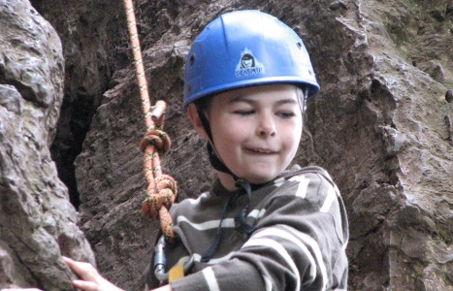 |  | 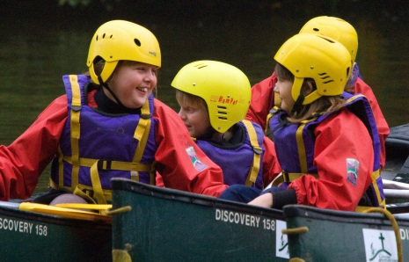
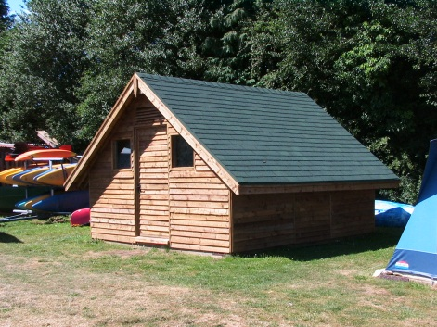 | 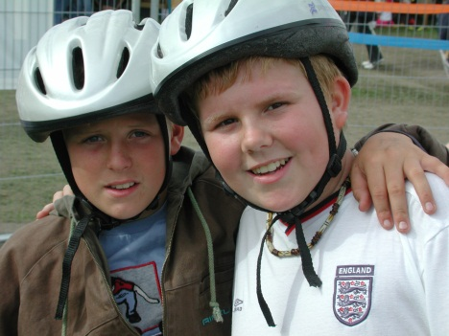 | 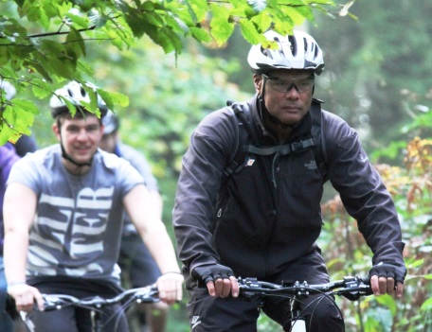

Residential Accommodation 2018
The Old Vicarage – indoor accommodation in our converted vicarage with bedding provided | £18.30 per person per night
Cross Meadow Camping Centre – camping in our canvas or timber tents with full use of the Cross Meadow Centre, including kitchen and dining room,  lounge and shower block  Off Peak Special – fully inclusive 3 day, 2 night ultimate team building experience available from November to February | £12.80 per person per night  £95.00 per child, teacher’s free
Orchard Wild Camp - wild camping with cold water and composting toilet  Orchard Wild Camp and use of Stables | £5.00 per person per night  £6.50 per person per night
Day Visitors | £5.50 per person per day
Babes in arms free, pre-school children half price for all types of accommodation.

Catering 2018
Catering is available upon request in the Old Vicarage and Cross Meadow | £5.25 per person per meal

Activities 2018
On-site activities
Archery  Bridge Building  Introduction to Bush Craft  Climbing Wall  Crate Stack  Forest Walk/Night Hike  Geo Caching  Low Ropes  Navigation  Photo Orienteering  Rocket Science  Team Building | £135 per group* per half day | *Each activity group caters for a maximum of 10 participants plus one adult leader.  Groups should choose two on-site activities per session. Each activity lasts for 1½ hours apart from our Night Hike which counts as a full session.
Off-site activities
Abseiling  All-terrain Biking⁺  Canoeing (Mallards Pike#)  Caving  Raft Building (Mallards Pike#)  Rock Climbing | £155 per group* per session | ⁺A good level of proficiency is needed for all-terrain biking  # The Forestry Commission impose a surcharge on adult groups using Mallards Pike
All Day/Night Specialist Activities
River Day |  |  | £310 per group* per day
Overnight Canoe & Bivi |  |  | £410 per group* per day
Mountain Day |  |  | £310 per group* per day
Gorge Walking |  |  | £310 per group* per day
Forest Adventure Day |  |  | £310 per group* per day
Symonds Yat Adventure Day |  |  | £310 per group* per day
Activity Surcharge
Please note that, for residential visits between Easter and the end of October, there is a surcharge of £5 per person per night if you choose not to have activities. Please see our terms and conditions.

Day Hire 2018
The Old Vicarage and Cross Meadow are available for day hire at ‘quiet’ times of year including use of the kitchen, dining area and lounge  The Stables is available throughout the year | £8.00 per hour  £125 per weekend  £6.00 per hour  £90 per weekend

How to book

- Contact us on (01594) 516162 or info@vineyhilladventure.org to check availability.
- Once we have agreed dates and requirements with you we will make a provisional booking and will email you a booking form.
- Return the completed booking form to us within 7 days of making a reservation. You will be invoiced for the deposit which must be paid within 14 days to secure your booking. Deposits are as follows:
  - Accommodation deposit – Old Vicarage & Cross Meadow £7.50 per person per night;
Orchard Wild Camp payment in full
  - Activities deposit – £70 per group per session
  - Day Hire deposit – payment in full

If you have any queries, please do not hesitate to contact us.

Accommodation 2018

The Christian Adventure Centre is a unique place to relax and discover the great outdoors through adventurous and challenging activities in a supportive and nurturing environment. Nestling between the River Severn and River Wye in the beautiful Royal Forest of Dean, we have 3 different types of residential accommodation and a day facility. Each unit is let exclusively to one group at a time:
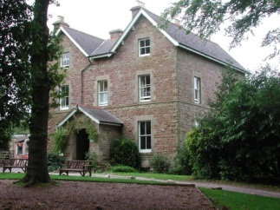
The Old Vicarage – indoor accommodation for up to 40 people

- Bedding is provided for you to make up beds, including sheets and pillowcases.
- Please bring your own towels.
- Wifi internet access, DVD player available.
- A floor plan for the Old Vicarage is available on our website.

Cross Meadow Camping Centre – camping accommodation for up to 72 people

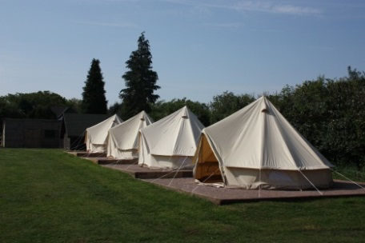
- Camping in our tents with the benefit of a large indoor facility including a fully equipped kitchen, dining area, lounge and shower block. Wifi internet access, DVD player, projector and whiteboard available.
- Our tents on Cross Meadow sleep 60, with two 6 to 8-person timber tents and eight 6-person canvas tents. You are welcome to bring your own tents as well.
- Please bring your own sleeping bag, pillow and roll mat.
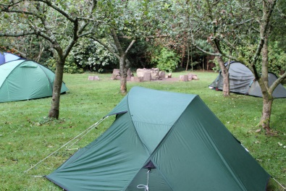
Orchard Wild Camp – wild camping for up to 24 people

The Orchard has a composting toilet and water supply – all you need for that ‘back to basics’ camping experience.
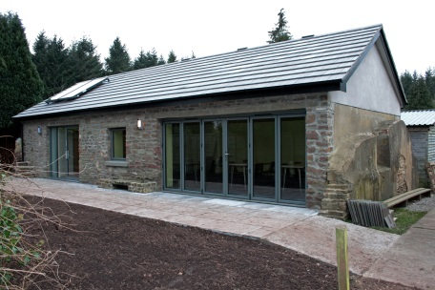
- Bring your own tent, sleeping bag and roll mat.
- Ideal for Duke of Edinburgh groups.

The Stables – the Stables is a contemporary venue with a meeting room, kitchenette, toilets and disabled facilities. It can also be used when staying on the Wild Camp.

- Meeting room with projector and whiteboard.
- Ideal for day groups and as a meeting venue or training facility for up to 30 people.

Activity Information 2018

Our activity sessions involve varying degrees of physical activity, and can be tailored to suit your group as part of a standard or individually designed programme.

Unless otherwise specified, activities take approximately 3 hours, starting and finishing at the Centre, with a 10-minute break. Session times are as follows:

Morning Activities: 9.15am – 12.30pm
Afternoon Activities: 1.15pm – 4.30pm
Evening Activities: 6.15pm – 9.30pm

Because your safety is of paramount concern to us, we have a strict ratio of 10 participants per instructor, plus one adult leader aged 18 years or over. Stringent safety regulations and guidelines from the relevant national governing bodies regulate the activities we offer. You can download a copy of our Risk Management Summary, which covers all our activities, from our website. You can participate in our activities with confidence. We are

- inspected regularly and approved by the Adventure Activities Licensing Service (AALS)
- approved to deliver the National Navigation Award Scheme
- members of the Mountain Leaders Training Association
- accredited by Learning outside the Classroom and have been awarded their Adventure Mark quality badge.

We must have a completed medical form for every participant. You can download the form from our website. Please hand the completed forms to a member of our staff when you arrive. You can also download a Kit List for all our activities from our website.

For groups which have special needs or behavioural issues, or which may need more individual attention, the number of participants in the group may be reduced and the number of leaders increased so that we can provide the best possible session for your group.

Our AALS licence only applies to children aged 8 and upwards, and we have limited equipment for children under this age. Some on-site activities are appropriate for a younger age group. Please let us know when booking your activities if age is an issue.

Most of our activities take place whatever the weather, but we reserve the right to offer an alternative activity or to reschedule sessions if the weather, or ground conditions, are unsuitable.

We can provide limited transport for off-site activity sessions, so we may ask you to provide your own transport; we will notify you in advance if this is the case. You may also be asked to drive one of our minibuses but we will contact you first to ensure you have a suitably qualified driver if so. If you require transport for anything else during your stay we can give you contact details for local minibus and coach hire companies.

Forest

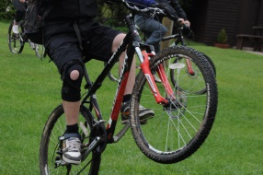
All-terrain Biking takes you through the forest by pedal power. Rides can be tailored to your group’s level of experience and fitness but all participants must be confident riding a bike. Participants may have to be excluded from this activity if their level of competence is insufficient. Physical effort – moderate to strenuous

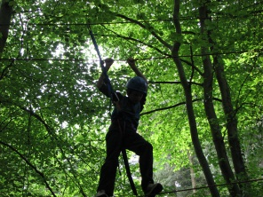
Archery is a sport for all ages and abilities. Our excellent outdoor range provides the opportunity to take part in this most ancient of skills using modern equipment, under the guidance of experienced, qualified instructors. We are able to offer basic introductory sessions or advanced skills coaching as required. Physical effort – moderate

Bridge Building involves getting from one side of a small quarry or stream to the other by setting up a rope bridge, using your initiative and developing your team building skills. Our instructors will provide basic equipment and give helpful hints! Physical effort – moderate to strenuous

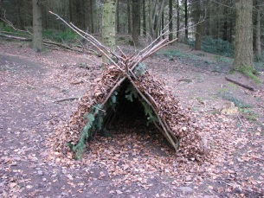
Introduction to Bush Craft is one of our more popular activities, introducing basic bush craft skills; how to find food and water, how to build a shelter and make a fire. Suitable for participants of all ages and abilities, it’s a great way to discover more about our natural environment. Advanced sessions are available on request. Physical effort – moderate

Crate Stack is a real team challenge which involves balancing at height. Everyone is involved in making a tower out of crates. See how high you can go, whether you are trying to beat your personal best or the group record! Physical effort – moderate

Geo Caching The future has arrived! Let satellites guide you around our high tech course, with a few surprises. Physical effort – moderate
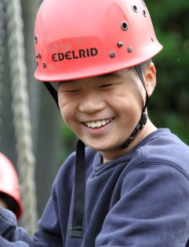
Low Ropes is a fun and memorable team building challenge on a low–level course which will help you to develop confidence as a group. It’s suitable for groups of mixed ability and age whether or not you have worked together before. Physical effort – moderate

Navigation will teach you the basic skills of map reading. You will use these skills to find the markers on our navigation course. Teambuilding elements can be included to make this activity more challenging for older groups or those with previous experience. Physical effort – moderate

Photo Orienteering Follow our fantastic trail of unusual views and strange sights – a new twist on map reading. Physical effort – moderate
Forest Adventure Day Enjoy a full day’s adventure exploring the forest through a variety of activities which could include biking, navigation, rafting and abseiling. A tailor-made day of challenging activities. Physical effort – moderate to strenuous

Forest Walk Let our instructors guide you through the forest and discover some of its history during the day, enjoy the setting sun of a summer’s evening or the thrill of a winter walk in the dark. This activity can be tailored to suit the needs and ability of your group. Physical effort – moderate to strenuous

Rocket Science A fun introduction to the science of rockets which will ignite your imagination. Through a series of interactive experiments, you will learn about and test launch our educational jet-propelled rockets. Physical effort – moderate

Team Building offers a variety of short initiative games and activities within the grounds of the Centre, which help to develop group skills such as communication, planning, problem solving and teamwork. Group goals are decided at the start of the session which can be tailored to develop leadership skills. Physical effort – minimal to moderate

Water

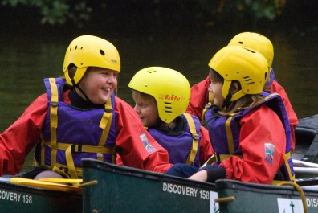
Canadian Canoeing with 2 or 3 in each boat is suitable for all ages and abilities, with a full safety brief and instruction on how to canoe, as well as lots of fun and games. The sessions take place on a local lake in the heart of the forest. Book early to avoid disappointment, as the Forestry Commission take lake bookings on a ‘first come, first served’ basis. Physical effort – moderate

Overnight Canoe Bivi is a journey in 2 or 3 person Canadian canoes along the river with an introduction to canoeing skills followed by the fun of sleeping under the stars and a morning paddle, before returning to the Centre by lunchtime the next day. You will provide your own food. This activity is dependent on river conditions. Physical effort – moderate to strenuous

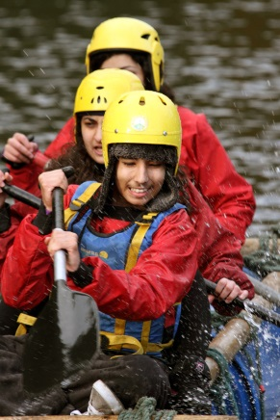
Raft Building is a great way to work on teambuilding skills. You will learn how to build your own raft, to get you to your destination across placid water, with various games on the way. You will get wet! Early booking is advisable as the sessions take place on a local lake in the heart of the forest which is let by the Forestry Commission on a ‘first come, first served’ basis. Physical effort – moderate

River Trip for more of an adventure, spend an instructor-led day on the river in our Canadian canoes. With a full safety brief and instruction on how to canoe, the River Trip is a wonderful opportunity to see the landscape from a different perspective. This activity is dependent on river and weather conditions. Physical effort – moderate to strenuous

Rock

Abseiling A slow descent over a vertical cliff face with varying heights of up to 90ft. Our instructors will help you to become relaxed in your technique and familiar with the equipment you will use, so that as your confidence builds you will develop greater control and a tremendous sense of achievement. Physical effort – moderate

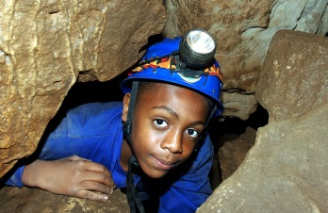
Caving using caves in the Symonds Yat area, with a variety of optional challenges, this is a fascinating activity for anyone wanting to crawl through holes and venture underground!! Our qualified and experienced instructors will help you to learn about the geology of the area from a completely different perspective. Advanced sessions are available on request. Physical effort – moderate

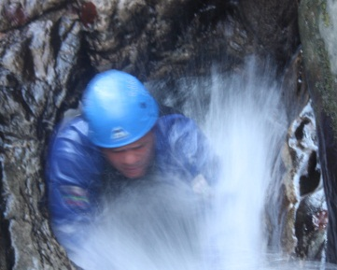
Climbing Wall is an excellent introduction to climbing skills, from balance to belay. Your group will learn to work together and operate as a team with all members being involved. Whilst one person is climbing, others learn the rope work skills that go with belaying. Suitable particularly for the novice climber. Physical effort – moderate to strenuous

Gorge Walking is a fun and challenging activity that gets the group working together, as you make your way up a stream or river, over, under or through different challenges. Always wet, always rewarding! Physical effort – moderate to strenuous
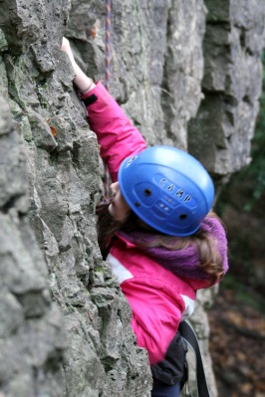
Mountain Day – a day out, tailored to your group’s interest and abilities in the beautiful Brecon Beacons or the wild and challenging Black Mountains. Navigation and map reading skills can be taught as we take you to the top to experience some amazing, fantastic views. This activity is weather dependant. Physical effort – moderate to strenuous

Rock Climbing on the cliff face at Symonds Yat enables your group to learn basic climbing skills, such as belaying on a rock face, whilst admiring the fantastic views and wildlife that inhabit the area around the cliffs. Advanced sessions are available on request. Physical effort – moderate to strenuous

Symonds Yat Adventure Day – get more out of an adventure day at Symonds Yat. Enjoy a full day of rock based activities which could include scrambling, climbing, abseiling and caving. Physical effort – moderate to strenuous

General Terms and Conditions 2018

Separate Terms and Conditions apply to our Schools Special Packages – please refer to our website or your booking form.
- Booking Accommodation  Due to high demand, reservations must be confirmed with a completed accommodation booking form within 7 days of making a reservation. You will be invoiced for the deposit, which must be paid within 14 days, upon receipt of your completed booking form. If you fail to confirm your booking on time the dates may be made available to others without further notice. All groups must give a best estimate of numbers on their booking form so that we can arrange appropriate levels of staffing.  - Booking Activities  Your choice of activities must be confirmed with a completed activity booking form, at least 3 months before your visit. You will be invoiced for the deposit, which must be paid within 14 days, upon receipt of your completed booking form.  - Activities Policy  Between Easter and the end of October you must book a minimum of 1 activity per person for a weekend visit & 3 activities per person during a mid-week visit lasting 4 nights. If you choose not to, you will incur an activity surcharge as specified in our price list.  - Catering  Groups are deemed to be self-catering unless otherwise arranged with us when booking.  - Payment  Payment of the final balance due must be made at least one calendar month before the date of your visit. We reserve the right to cancel your visit if the final balance is not received when due, in which case your deposit will be forfeit. Written notice of any variation in numbers must be given before your final payment becomes due, failing which the full balance invoiced will be payable. If you bring additional guests a supplemental invoice will be issued after your visit for payment within 14 days.  - Minimum Charges  To make it financially viable for smaller groups to visit the Centre we have a minimum charge for 15 people per night per group for accommodation in the Old Vicarage and on Cross Meadow. There is no minimum charge on the Orchard Wild Camp.  If you hire both the Old Vicarage and Cross Meadow the charges will be as follows:  - During the camping season (April to October) you will be charged for a minimum of 55 people, of which at least 20 will be at Old Vicarage prices.  - Outside the camping season (November to Easter), if you wish to book the Cross Meadow Camping Centre and field, as well as the Old Vicarage, you will be charged £70 per day, or £120 per weekend in addition to the usual accommodation charges for the Old Vicarage.  - Arrival and Departure Times  - Arrivals: Mondays from 10am; Fridays from 4pm.  - Weekday departures: Please vacate your rooms/tents by 9.30am.  - No arrivals or departures after 8pm. | This allows us to check over the site, and ensure it is ready for the next group. Please consult us about special arrangements if required – it may be possible to negotiate different times. A member of staff will brief the group on arrival and debrief you on departure.  - Cancellation of Accommodation by Client  All cancellations must be made in writing. The deposit is non-  refundable. If less than 3 months’ notice of cancellation is given, then the full accommodation fee will be charged.  - Cancellation of Activities by Client  Cancellation of activity sessions within 3 calendar months of booked dates will result in the loss of your deposit. If you cancel within 2 calendar months of the booked dates you will be charged the full cost of all activities booked.  - Cancellation by the Centre  Whilst every effort will be made to ensure your visit takes place, we reserve the right to cancel at any time. In this event, as much notice as possible will be given and you will be offered either a full refund of fees or a mutually agreed alternative booking date. In the unfortunate event that we are unable to provide a booked activity session you will be offered an alternative or a full refund of the session fee. We regret that our liability does not extend beyond this.  - Equipment  You must report, and will be required to pay for, any equipment lost, broken, stolen or damaged. Substitutes cannot be accepted.  - Car Parking  Cars are NOT ALLOWED on the campsite. Please park in the car park. Cars and contents are parked at owners’ risk. The parking area is limited; please share transport wherever possible.  - Noise  Please respect our neighbours and avoid all unnecessary noise. Activities should be peaceful by 9.30pm, with quiet on-site from 10pm - 8am. We have a noise management policy which you will be required to sign and adhere to during your stay. If a member of staff has to be called to the Centre between the hours of 10pm and 8am, a call out charge of £50 may be levied.  - Camp Fires  A camp fire is permitted within the guidelines which are clearly displayed in the Centre.  - Toilets  Paper towels, sanitary towels, nappies etc, are NOT to be flushed down the toilets; please use the appropriate bins provided. Paper hand towels and toilet rolls will be provided.  - Rubbish and Recycling  All groups are expected to comply with the Centre’s recycling policy, which will be explained on arrival. Any rubbish which cannot be recycled should be bagged up and placed in the red bin provided. Please use the bins and keep the site free of litter.
- Cleaning/Clearing up  It is your responsibility to leave the site clean and tidy and ready for the next group. Please refer to the cleaning checklist on site. We provide general cleaning materials. There is a dishwasher, washing machine and tumble drier in the Old Vicarage only for which you will need to provide your own tablets/powder.  - Group Leaders  Each group must appoint a group leader who will be responsible for behaviour during activities, for liaising with Centre staff as necessary and for ensuring compliance with these Terms and Conditions.  - Telephone  There is an emergency telephone located outside the old office, but group leaders should have a mobile with them for any other calls. Mobile phones are not to be used during activity sessions. Please ensure that your group leader brings a mobile telephone so that people at home can get in touch during your stay in case of emergency outside normal office hours, when on call cover is provided for the group only.  - Child Protection  You must comply with the Centre’s Safeguarding Policy, a copy of which can be found on our website. We require groups to indicate on the booking form that they have appropriate safeguarding policies and procedures in place, and that all adult leaders are DBS checked.  - Fire  In the event of fire make sure the building or tent involved is EVACUATED. Raise the alarm and dial 999. Leaders should do a roll call. Contact the Duty Manager as soon as possible to give details, the on call telephone number will be given to you on arrival. All groups are advised to do a fire drill.  - First Aid  You must have a designated first aider on your staff team. All of our instructors are trained in first aid and will be responsible when leading an activity session. | - Accidents  All accidents must be reported to the Duty Manager at the time and be entered into the accident book.  - Insurance  We have Public Liability Insurance cover up to £5 million. Personal accident, theft, loss or damage to personal property is not included. Groups are advised to take out their own public liability, personal injury and cancellation insurance.  - Smoking  Smoking is not permitted on any activity. Smoking is not allowed in Centre buildings and is strongly discouraged on Centre premises and grounds.  - Drugs and Alcohol  The possession or use of any banned substances will not be tolerated. Under-age drinking or possession of alcohol is not permitted. Centre staff have the right to ask those responsible to leave the site immediately.  - Disruptive Behaviour  Centre staff have the right to ask those whose behaviour is not acceptable to leave the site immediately.  - Day Visitors  All day visitors will be charged at the rate specified in our price list.  - Dogs  The Centre and the grounds are pet free zones, and no animals are allowed on site except for working guide dogs.  - Internet Use  Whilst we provide limited internet access, by using this service you agree to indemnify the Centre against any claims by third parties arising from your access to and/or use of this service. You agree that the Centre has no responsibility whatsoever for any content or services offered on the internet. We reserve the right to withdraw internet access in the event of inappropriate use.

The Christian Adventure Centre
The Old Vicarage
Viney Hill
Lydney
Gloucestershire
GL15 4NA

Tel: (01594) 516162
Email: info@vineyhilladventure.org
www.vineyhilladventure.org

Climbing/Caving/Trekking/Watersports
Confirm on: Tel 029 2075 5715
AALA No: L12068/R1023

